**Efficax error list: -**

1. Picture Library errors.
   1. Some of the blocks have irrelevant pictures and please change it to the respective image. Screenshot attached below for reference.

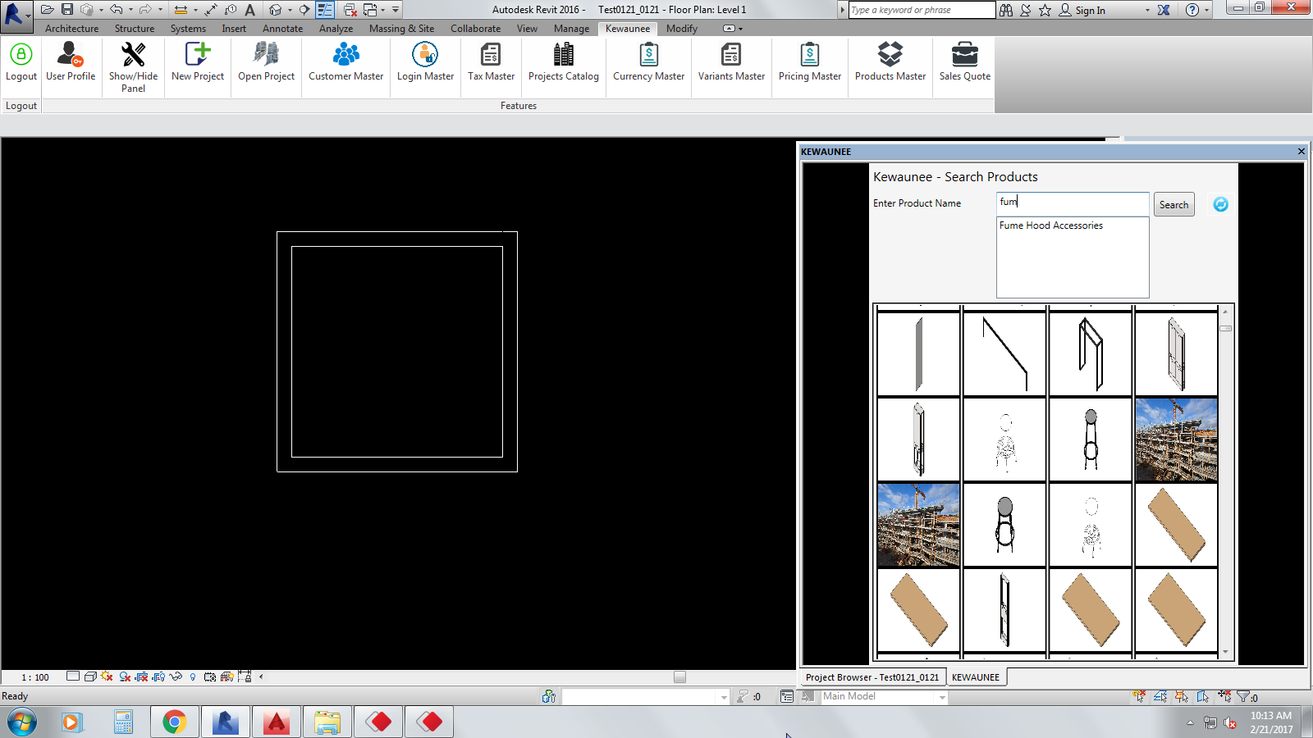

* 1. “Search” filters need to be add according to the category-wise ( refer to the grouping excel sheet) to narrow down the selection of items.

1. Revit and SQL errors randomly.
   1. Sometimes, when we open any option like “New project”, “import project” etc., a Revit error occurs and the application gets close instantly. This error occurs randomly.
2. Costing interface errors.

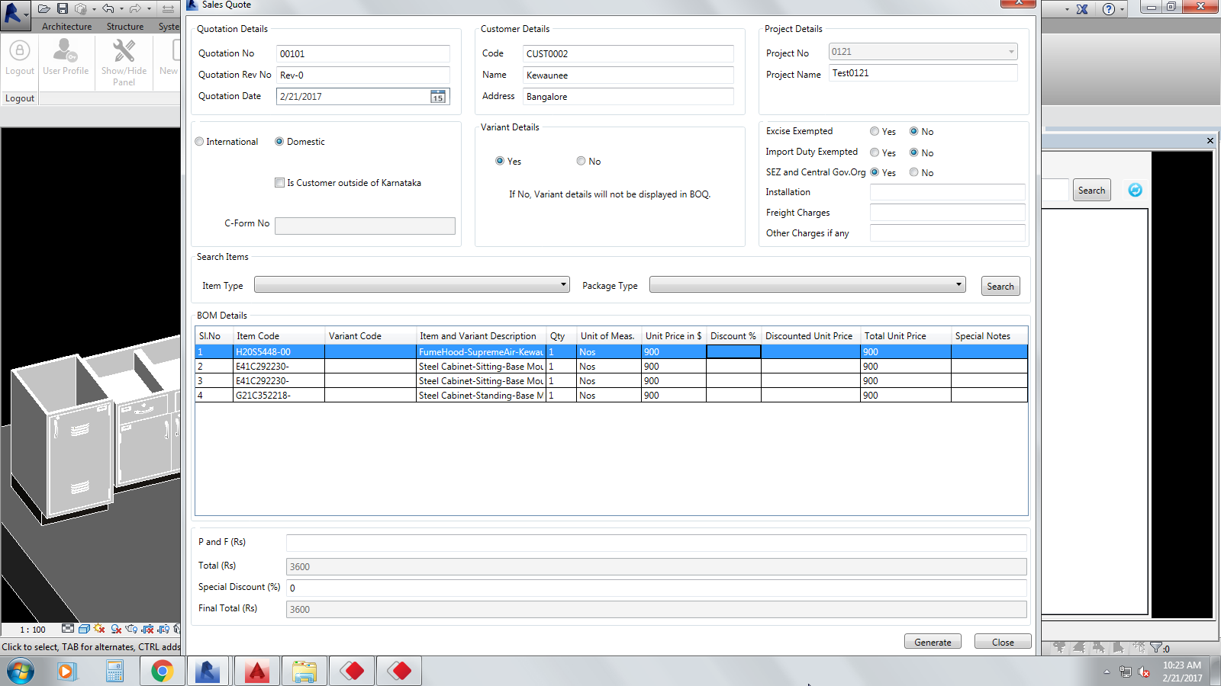

* 1. “Package” filters (i.e. fume hood, furniture, etc.,) and item type (i.e. indigenous & import) filters are not working.
  2. In the BOQ list, we are not able to resize the table manually. Please provide that option.
  3. In “Description” column, the item code description should come first and a “/” separator sign between all variants description got selected followed by the item description.
  4. The “Description” text should get wrap automatically to see the full context properly.
  5. “Special notes” column also should get wrap text automatically to see the remarks written in the column.
  6. When clicked the “Generate quote”, Revit error occurs and attached the screenshot below for your reference.

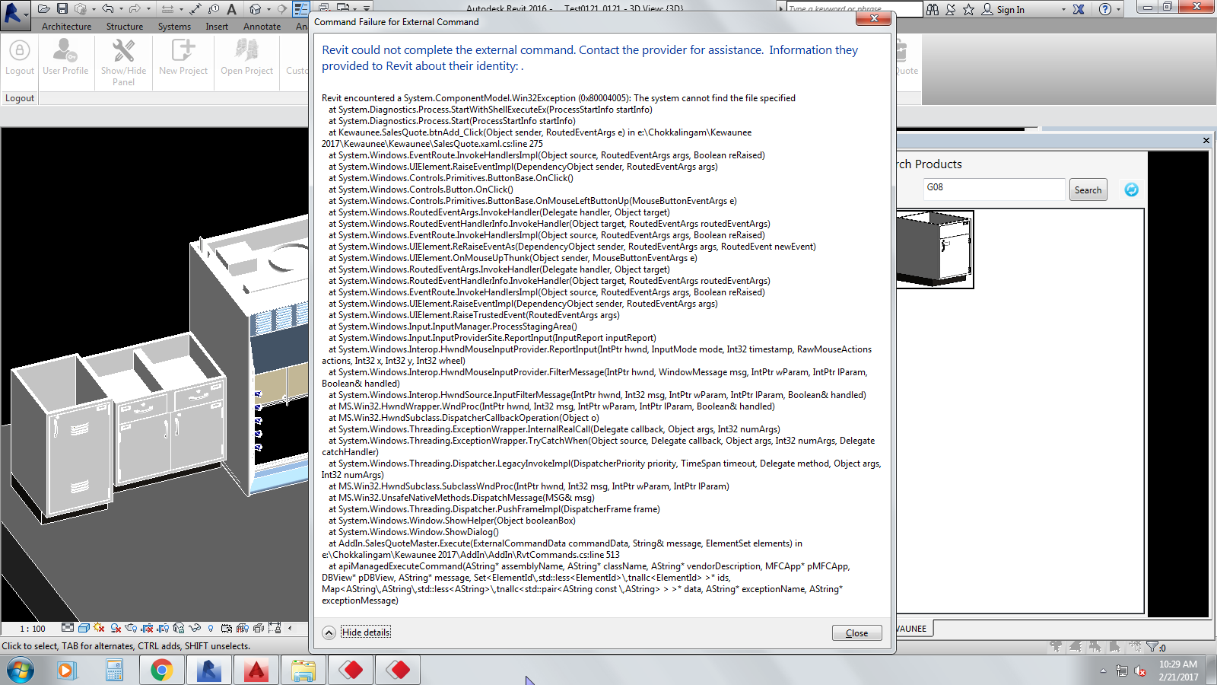

* 1. Use the attached “logo” file in the report since you requested for a low-profile size picture.

C:\Users\Admin\AppData\Local\Microsoft\Windows\INetCacheContent.Word\KSCI.PNG